Christmas Home Learning Challenges



GCSE SUBJECT: FINE ART

**HOME LEARNING TASK:**

**For our first lesson back after the holidays….complete all unfinished work for your component one (60% of your actual GCSE grade) for teacher review.**

**Success Criteria:**

* **Final piece finished-all colour and outline added**
* **All sketchbook pages are fully finished**

**\*\* You need to take your books and final pieces home to complete this \*\***

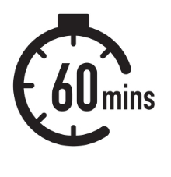

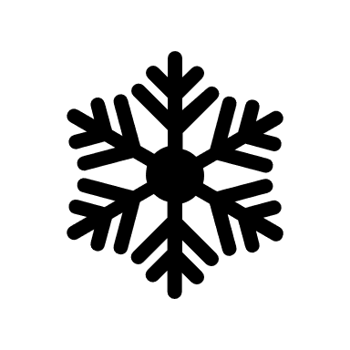**CHECKLIST**

Subject Priorities from the Mock Exam:

* Ensure you complete all unfinished work in your books and stick any work on paper into books (good presentation)
* Ensure planning pages for your final piece are in your books-if you need help with this see Mrs Cooper or Miss Hedley

 Something to read:

<https://www.bbc.co.uk/bitesize/guides/zpcndxs/revision/1>

Useful to read before we start our externally set task in January 2024:

<https://www.bbc.co.uk/bitesize/guides/zf7yrmn/revision/1>

NEA guidelines that all students must adhere to for all their Art GCSE components: <https://www.jcq.org.uk/wp-content/uploads/2022/08/IFC-NE_Assessments_2022_FINAL.pdf>