Christmas Home Learning Challenges



GCSE SUBJECT:

**CHECKLIST**

Subject Priorities from the Mock Exam:

* Practice exam skills, especially for 12 mark questions

* Embed the use of quotes within 5 and 12 mark questions
* Revise previous content, including a focus on key words

**HOME LEARNING TASK:**

* **Complete practice timed questions from the personalised question pack provided in class**

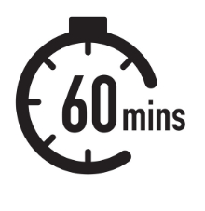

**Subject Enrichment Challenge:**

Something to read: [insert link / reference to reading material)

Something to watch / listen:

BBC documentary exploring key Christian beliefs and practices: <https://www.youtube.com/watch?v=LAoE7n3HEH0>

BBC documentary exploring key Islamic beliefs and practices: <https://www.youtube.com/watch?v=lHH8HixNVho>



**Making Notes: Wider Reading (Enrichment Challenge)**

Use the following template to help you make notes on each article / lecture / podcast that you engage with to develop your understanding of the subject’s key ideas and concepts and to apply it to your study in lesson.

**Summary:** *Summarise the knowledge you have now learnt relating to this topic.*

**Key Ideas:** *In this section, record the main ideas explored in the text. Consider key words and vocabulary, questions, comments and the big ideas which the text explores.*

Notes: I*n this section, write notes from the article / video / podcast. Try to keep your writing in note-form. This will ensure you can record as much information as possible.*

**To do:**

*(What do I need to do to apply these ideas to my areas of study/ what questions do I still have for my teacher?)*

Name:

Subject & Topic: