Christmas Home Learning Challenges



GCSE SUBJECT: Combined Science (F) Biology

**CHECKLIST**

Subject Priorities from the Mock Exam:

* The heart

* Enzymes
* Digestive system

**HOME LEARNING TASK:**

**Complete activities I. and II. in the PIXL Independence resource.**

**Extension: Complete activity IV.**

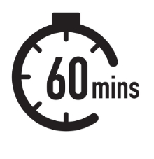

**Subject Enrichment Challenge:**

Something to read: [insert link / reference to reading material)

Something to watch / listen: <https://www.youtube.com/watch?v=VLK2wANjQm0&t=35s>

<https://www.youtube.com/watch?v=4ui4oSHHnzA>



**Making Notes: Wider Reading (Enrichment Challenge)**

Use the following template to help you make notes on each article / lecture / podcast that you engage with to develop your understanding of the subject’s key ideas and concepts and to apply it to your study in lesson.

**Summary:** *Summarise the knowledge you have now learnt relating to this topic.*

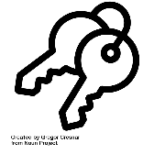**Key Ideas:** *In this section, record the main ideas explored in the text. Consider key words and vocabulary, questions, comments and the big ideas which the text explores.*

Notes: I*n this section, write notes from the article / video / podcast. Try to keep your writing in note-form. This will ensure you can record as much information as possible.*

**To do:**

*(What do I need to do to apply these ideas to my areas of study/ what questions do I still have for my teacher?)*

Name:

Subject & Topic: