Group Name:_________________

Duke of Edinburgh’s Award.

Producing an Assessor’s Information Pack.

Introduction.
- An assessor will be impressed if you send information about your expedition in an organised way with everything he/she needs to assess you.
- The quality of your work is important, as first impressions count.
- The Information Pack will need to be a group effort.

The process.

Assessment dates and venue.
- The date will be given to you by Mr. McNaughton.
- He will also arrange an Assessor for you.
- So that it is easy to arrange transport and supervision, Mr. McNaughton will suggest an area for you to walk in. For the Bronze assessments in ........., this will be ........................................................ area Your campsite will be ...................................................................................
Your start point will be:...................................................................................
Your finish point will be......................................................................................
Making Contact.
- Once you have the name of an Assessor, it is up to your group to make contact.
- You are expected to liaise with the assessor directly, letting Mr. M know about any developments.
- Phone, write to or email the assessor as soon as you have had the person confirmed. This is just to make contact.
  - Introduce yourselves – where are you from, confirm the date of the assessment, how many in your group etc.
  - Ask politely whether the Assessor is prepared to assess your group and suggest that your group is in the process of preparing details about routes etc.
  - Ask about the date that the Assessor would like your Assessment Pack – normally this will be 6 weeks before the expedition.
Note that all Assessors are experienced and DofE registered expedition leaders and that they are all Police checked and cleared, so they are reputable people.
Assessors don’t get paid for assessing you – they do it for free because they believe that young people need to be invested in. Be grateful accordingly.
Preparing the pack.
- 1 )Front page – school name, assessment dates, area in which you will be assessed. Some groups give themselves a Team Name – e.g. The Walking Wonders.
- 2) Inside front page – names of each of you doing the expedition. If you want, you can include a small photo of each of you and a brief description of your interests. Give an email address or phone number of one person in your group who is willing to act as group contact. If you are uncomfortable doing this, please discuss with Mr. M
- 3) Project details – the project is an important part of the assessment. Each person must either do an individual project or must take part in a group project. If you take part in a group project, you must have a definable part of it and take responsibility for your section.
  - Say what you intend to study.
  - Say what each person is focusing on.
  - What do you intend to find out?
  - How you will gather information?
  - Will you need any special equipment? Make a list.
  - How will you present the findings after the expedition?
Remember – you can do a great expedition but fail on the project, so make sure you plan this well.
- 4) Produce a route tracing – this can be a traditional overlay on tracing paper (which is why it is called a tracing) although most people these days do a copy of their route and used a highlighted pen to show the route. On the route tracing you should show:-
  - The start point of each day.
  - The end point of each day.
  - The beginning and end of each ‘leg’.
  - Don’t obscure the features on the map copy – use a highlighter or use small circles at intersections.
  - The direction of travel.
  - Each leg should be labelled and correspond to the route card.
  - Escape routes – at key points where you would go to seek help in an emergency.
  - Say which map the copy has been taken from – e.g. 1:25000 Explorer Sheet 178.
  - Put your group names at the top, the assessment date and school. (Don’t forget that the Assessor may be assessing other schools too!)
  - You may have to tape sections together to cover the whole route.
- 5) Produce route cards for each day – a route card is the best way to make sure that you are planning the correct distance and helps the Assessor work out where you will be at any time.
  - A big mistake made by many groups is that only one or two persons often take responsibility for the route card. This means that the couple of people who plan the route are really familiar with it and the others often don’t have clue as to where they will be going. The others often have difficulty working out timings because they haven’t done any of the planning.
  - Plan at 4km/hour.
  - This means that you need to use the following timings:-
    - 4km will take 1 hour to walk.
    - 1km will take 15 mins. to walk.
    - 100m will take 1.5 mins. to walk.

On a 1:25,000 map then:
- 1km is represented by 40mm
- 100m is represented by 4mm
- At Bronze level, bearings are not needed – just give a general compass direction of your starting off direction – e.g. NW or SSE.
- Heights are given on your map by contour lines – each line on your map represents a height gain/loss of 5 metres. If you are going up a steep slope, add –
  - 1 minute for 2 contours crossed.
  - At Bronze level the hills are not normally steep enough to require any additional time for going downhill.

These guidelines for working out how long it takes to walk your route are called Naismith’s Rule. (William M. Naismith was a Scottish Mountaineer who in 1892 developed a rule of thumb for calculating distances on a mountain walking expedition.)
- Make sure your grid references are given the correct way around. Remember – ‘go along the hall and up the stairs’.

- 6) Menus – produce a page that has your choice of food for the expedition.
        - Give detail of each meal and approximate quantities.
        - Don’t forget to try to impress your Assessor by showing what you can cook and prepare. You can bring pre-prepared food as long as it isn’t likely to go off – avoid fresh meat in the summer. (This also goes for chocolate and cheese if the weather is likely to be hot)

        - Pot noodles are frowned upon by most Assessors as they are not very nutritious and take no skill to cook. Don’t take them!

        - Remember that you are going to burn lots of calories doing an expedition. Breakfast is really important and eating little and often is a good thing to do. Avoid fried food, especially at breakfast time unless you are willing to get up 30-40 minutes earlier, so that you can clean the pans afterwards.

- 7) Provide a kit list – use my list to help you. Work out what you will each need and make a list of who is taking what.

Examples.
An example of a correctly completed Route Card

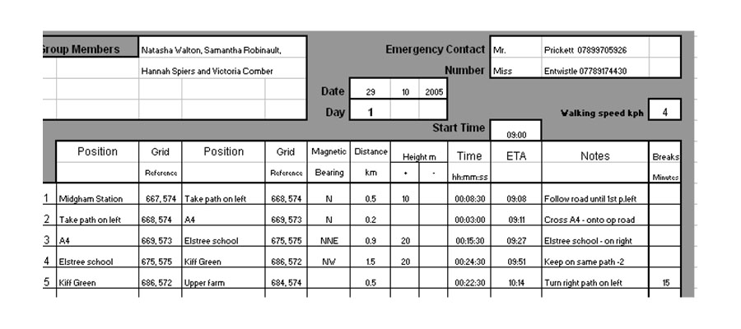

An example of a route ‘tracing’.

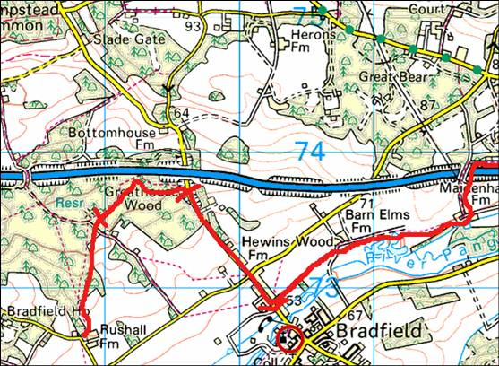
1
2
3
4

