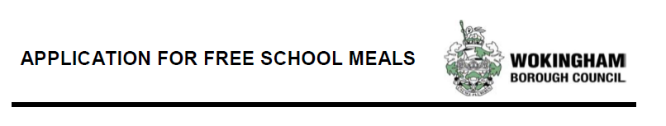
Dear Parent/Guardian,

We want to make sure we are providing your child with the best education and support we can. Healthy school food has obvious benefits and can help pupils establish healthy habits for life and can also help to improve pupils’ readiness to learn.

Families who received certain benefits may be eligible for free school meals.

Registering for free meals could also raise additional money to fund valuable support like extra tuition, additional teaching staff or after school activities. This additional money is available from central government for every child.

Please make sure the information you provide is the same as what you provide to DWP & HMRC and is legible.

Please do not put down foster parent if you are a family member informally taking care of the child(ren) so there are no hold-ups in doing the checks. The eligibility of children in local authority care is at the council’s discretion.

Please enter a letter into each square and if your surname has two parts make sure you include a space.

PARENT’s details

Surname
Forename
Date of Birth | D | D | / | M | M | / | Y | Y
Relationship

 | Letters |  | Numbers |  |  |  |  |  | Letter
NI number | A | A | N | N | N | N | N | N | L

If you are making a claim for asylum, an eligibility check MUST require a NASS number even if you have another Home Office Reference number. Please don’t send in a request until you have one. The first two digits is the year, the third and fourth digits is the month.

NASS number | Y | Y | M | M

CHILDREN’s details

Please ensure you send a separate application form to all relevant schools and include every child for whom you would like to be checked as their eligibility status will be based on your current circumstances. If you get one child checked and they are eligible it does not automatically mean siblings who attend a different school are also eligible if you don’t apply.

Surname | Forename | Date of Birth
 |  | _____ / ____ / ________
 |  | _____ / ____ / ________
 |  | _____ / ____ / ________
 |  | _____ / ____ / ________

Declaration

I CERTIFY THE INFORMATION GIVEN IS TO THE BEST OF MY KNOWLEDGE IS COMPLETE AND ACCURATE.

I confirm I will inform the school immediately of any change in circumstances.

I agree that you will use the information I have provided to process my claim for free school meals and will contact other sources as allowed by the law to verify my entitlement.

I understand the results of any free school meal eligibility check may also be used to assess my entitlement to claim other benefits related to my child’s education, eg. School travel.

Signature of application: ________________________________________________

Date: ______/______/____________

We are committed to ensuring the personal and sensitive information that we hold about you is protected and kept safe and secure, and we have measures in place to prevent the loss, misuse or alteration of your personal information. We will use the information you provide to assess entitlement to free school meals.

PLEASE RETURN THIS FORM TO THE SCHOOL

IF YOU ARE INELIGIBLE PLEASE DIRECT QUERIES THROUGH THE SCHOOL.
DO NOT CONTACT THE COUNCIL DIRECTLY

November 2019

