Data Collection Transfer Document (Part 3) - Student Information

Once the document has been downloaded and saved, please remember to save the information as you complete each section with your child and that you ensure you are happy for us to retain this information on our records. Please return the completed form via email Dataoffice@emmbrook.wokingham.sch.uk

Important information about yourself.

My full name is:

My Primary School is:

If you have any brothers or sisters who already attend The Emmbrook School please provide their name/s and tutor groups below.

Their name is:

Their current year and Tutor Group:

The people you know and the things you do.

Are there any people you know who will be starting The Emmbrook School with you in September? If there are, name two people who you work well with:

1.

2.

Please list below all your hobbies and interests:

Please list below the things you enjoy doing at school:

Please list below the things you least like doing at school:

Please list below any sports clubs, dance groups or societies that you belong to:

Please list below if you have performed in any drama or dance productions. Were they inside or outside of school:

MUSIC DEPARTMENT

We would like to find out more about your interests and involvement in Music, both inside and outside school?

Do you play an instrument? If you do please list below the instrument/s you play:

If you do play an instrument please list below the standard/level you have achieved (eg grades passed or the approximate standard you have reached):

Do you have regular lessons with a qualified teacher? If yes, please list below who they are with (eg Berkshire Maestros, School Teacher, Private Tutor, etc):

If you would you like to learn to play an instrument or learn a new instrument please list which one/s below:

Do you sing in a choir or play in a group either inside or outside school? If you do please list below its name and whether it is inside or outside of school:

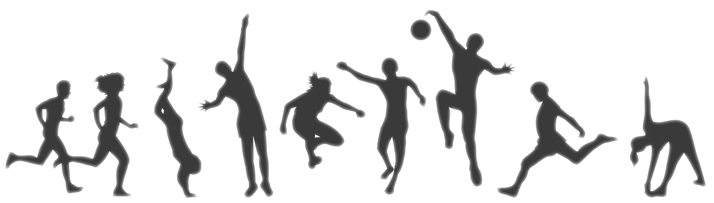

PHYSICAL EDUCATION Department

We would like to find out more about your interest and involvement in physical activity, both at school and in the community. If you do take part in any sport or physical activity inside or outside school hours please enter either the number 1, 2 or 3 in the box by those that you do or have done in the last year.

1 = Inside School 2 = Outside School 3 = Both Inside and Outside School

Athletics/Running |  | Football |  | Gymnastics |  | Rugby
Badminton |  | Golf |  | Judo/Martial Arts |  | Swimming
Cricket |  | Hockey |  | Netball |  | Tennis
Dance |  | Horse Riding |  | Rounders |  | Trampolining
Other, please indicate:

If you have taken any performance-based exams or been selected to compete at school, district, county, regional or national level please detail your achievements below.

