Christmas Home Learning Challenges



GCSE SUBJECT: Music

**CHECKLIST**

Subject Priorities from the Mock Exam:

Writing 8 marker answers for set works – content, structure etc

Further revision and consolidation of styles/composers/genres listed in AoS4 in particular

Development of compositional planning and ideas; considering what went well when composing the free-choice piece , and what to avoid for the AQA brief composition

**HOME LEARNING TASK:**

**Planning, composing initial ideas (melodies/chord sequences etc) for the second AQA brief composition. Use the planning sheet to help plan!**

**Regular practice to prepare for solo/ensemble performance coursework**

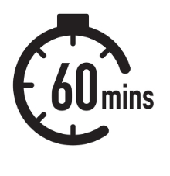

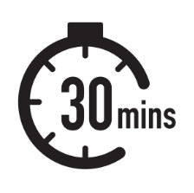

**Subject Enrichment Challenge:**

Something to read: [insert link / reference to reading material)



Ensure that the listening of pieces listed on Satchel of British composers in AoS4 has been completed as per instructions.

**Making Notes: Wider Reading (Enrichment Challenge)**

Use the following template to help you make notes on each article / lecture / podcast that you engage with to develop your understanding of the subject’s key ideas and concepts and to apply it to your study in lesson.

**Summary:** *Summarise the knowledge you have now learnt relating to this topic.*

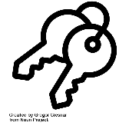**Key Ideas:** *In this section, record the main ideas explored in the text. Consider key words and vocabulary, questions, comments and the big ideas which the text explores.*

Notes: I*n this section, write notes from the article / video / podcast. Try to keep your writing in note-form. This will ensure you can record as much information as possible.*

**To do:**

*(What do I need to do to apply these ideas to my areas of study/ what questions do I still have for my teacher?)*

Name:

Subject & Topic: