Christmas Home Learning Challenges



GCSE SUBJECT: Mathematics – 11xy/Ma3-2 Mrs.Chillarigae

**HOME LEARNING TASK:**

* **Complete the 2 Focus Task booklets attached on SatchelOne.**

**(Focus Tasks 1&2 and Focus Task 3).**

* **Complete the practice paper attached on SatchelOne.**

**CHECKLIST**

Topic Priorities from the Mock Exam:

* Basic Number Skills (MW clips 5, 28, 78, 138
* Basic algebra skills (MW clips 33, 93, 94, 134, 157)

**Subject Enrichment Challenge:**

Something to watch / listen: This is the topic we will be doing in the new term. watch these videos on Real life Graphs! You can also have a go at the interactive questions on Mathswatch.

<https://corbettmaths.com/2021/11/18/real-life-graphs-video/>

MathsWatch Videos: KS3 Clips - A21a, A21b GCSE clips – 6a, 6b, 96, 97

**Making Notes: Wider Reading (Enrichment Challenge)** 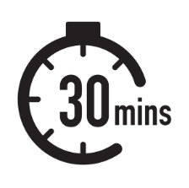

Use the following template to help you make notes on each article / lecture / podcast that you engage with to develop your understanding of the subject’s key ideas and concepts and to apply it to your study in lesson.

**Summary:** *Summarise the knowledge you have now learnt relating to this topic.*

Name:

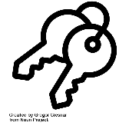**Key Ideas:** *In this section, record the main ideas explored in the text. Consider key words and vocabulary, questions, comments and the big ideas which the text explores.*

Notes: I*n this section, write notes from the article / video / podcast. Try to keep your writing in note-form. This will ensure you can record as much information as possible. You could write a worked example question with the steps to solving this*

**My Question:**

*(Write your own question which can be solved by someone else in your class in January.)*

Subject & Topic: